A000-Eur-Greece-Asklepios-statue by Diogenes-marble-4th c BCE

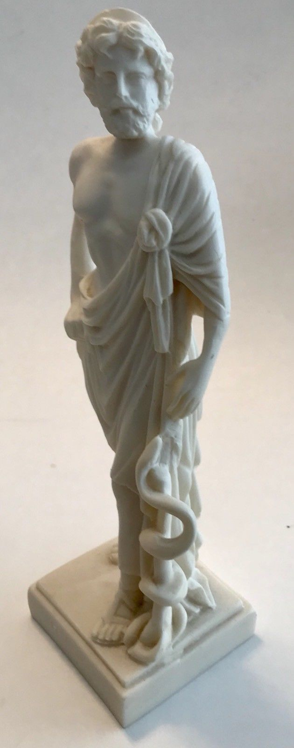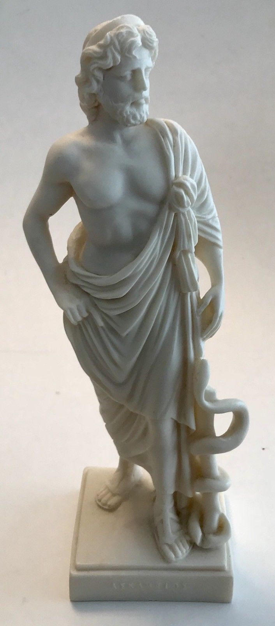 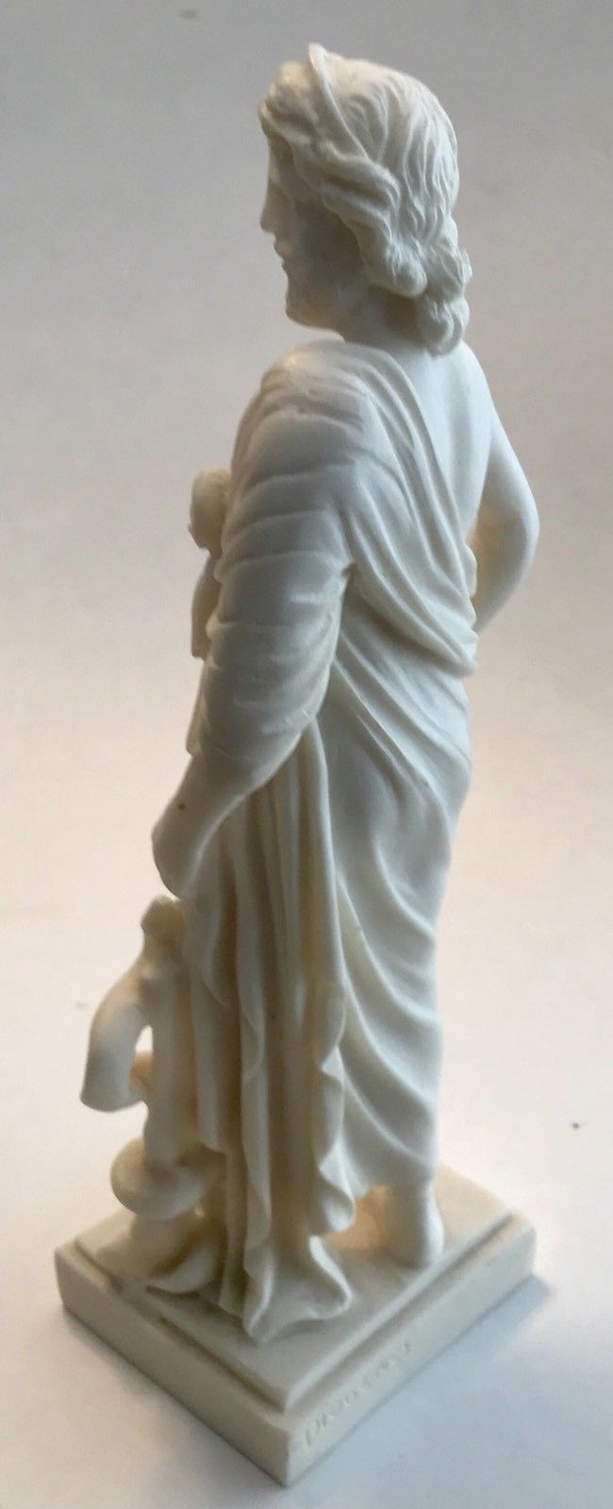 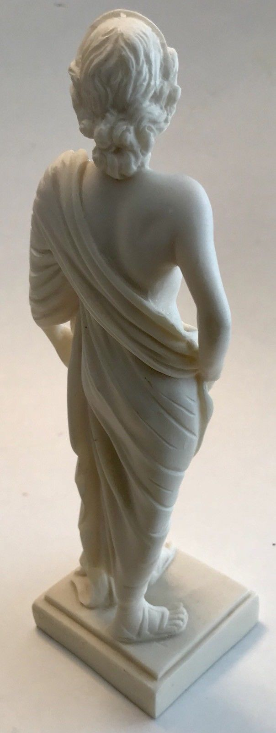

**Case No.:**

**Accession No.**

**Formal Label:**

**Display Description:**

Asklepios (Asclepius) was a Greek doctor of medicine of the fifth c BCE who represents the healing aspect of the medical arts. He had three daughters who also became known for their healing capabilities: [Hygieia](https://en.wikipedia.org/wiki/Hygieia), [Iaso](https://en.wikipedia.org/wiki/Iaso" \o "Iaso), [Aceso](https://en.wikipedia.org/wiki/Aceso), [Aglæa/Ægle](https://en.wikipedia.org/wiki/Aglaea" \o "Aglaea), and [Panacea](https://en.wikipedia.org/wiki/Panacea)). He founded the Asklepiades (Asclepiades), an ancient guild of doctors, *Therapeutai* (Θεραπευταί), who were trained in trditioal medical arts as well as in psychology.

When the man, Asklepios, died, a mythology was invented that explained how his miraculous achievements in medicine were made possible in the same way that a mythos was invented about the man, Jesus of Nazareth. Henceforth, Asklepios was likened to the Etruscan god [Vediovis](https://en.wikipedia.org/wiki/Vediovis" \o "Vediovis) and the Egyptian [Imhotep](https://en.wikipedia.org/wiki/Imhotep) and the son of Apollon and the Trikkaian (Triccaean) princess Koronis (Coronis). His mother supposedly died in labor and when she was laid out on the pyre, Apollon cut the unborn child from her womb. From this Asklepios received his name which means "to cut open." Asklepios was raised by the centaur Kheiron (Chiron) who instructed him in the art of medicine. He grew so skilled in the craft that he was able to restore the dead to life which was hypothesized to have been a crime against the natural order according to Greek mythologists and so they invented his death as the result of Zeus killing him with a thunderbolt.

In fact, the cult of Asklepios was diffused throughout the Mediterranean after the Peloponnesian wars when so many were afflicted by wounds or disease. A special cult was developed on an island in the Tiber River in Rome where a hospital in the form of a ship that had brought it to Rome was built in Asclepius. This ship hospital became so popular when Christianity arrived in Rome that the Church hierarchy tried to destroy the ship and remake it in the name of their invented god, Christ. The remnants of the ship can still be seen on the island where a Christian hospital has been built over it.

**LC Classification:**

**Date or Time Horizon:**

**Geographical Area:**

**Map:**

**GPS coordinates:**

**Cultural Affiliation:**

**Media:**

**Dimensions:** H 22cm, 8.7 in

**Weight:** 383 gm, 0.84lb

**Condition: reproduction**

**Provenance:** Greece

**Discussion:**

**References:**